**wkhtmltox installation**

**Version 1.0**

**Version History**

|  |  |  |  |
| --- | --- | --- | --- |
| **Version** | **Date** | **Handled by** | **Comments** |
| V1.0 | 26-Aug-2019 | ZL Chen | First version release. |
|  |  |  |  |

Precondition Setting:

Please make sure the DUT is connected to the internet.

Please follow the installation steps as below:

Step 1:

Please find the “wkhtmltox-0.12.5-1.msvc2015-win64.exe” under the installer folder, and then double click this one.

Location: .\automation\installer

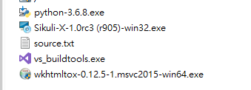

Step 2:

Please tick the checkbox, and then click the “I Agree” option.

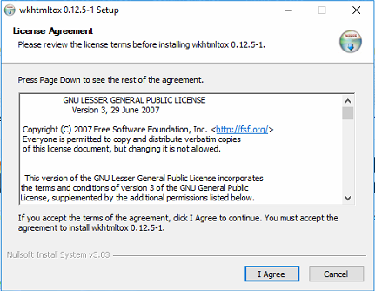

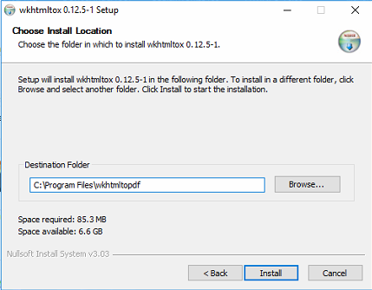

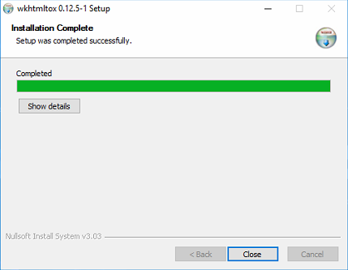

Step 3:

Join the “C:\Program Files\wkhtmltopdf\bin” of path.

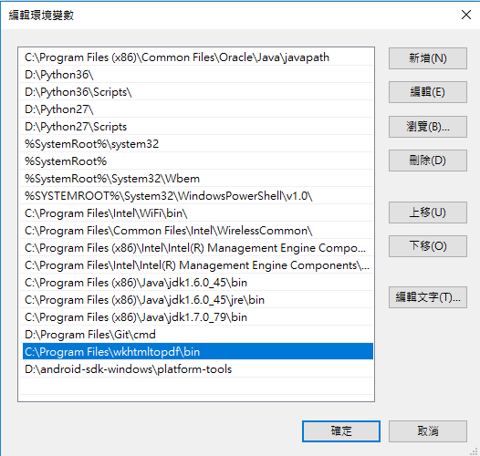

Step 4:

Make sure the “wkhtmltoimage” command can be worked.

